PHOTOGRAPHS REFERRED TO IN THE COVERING LETTER
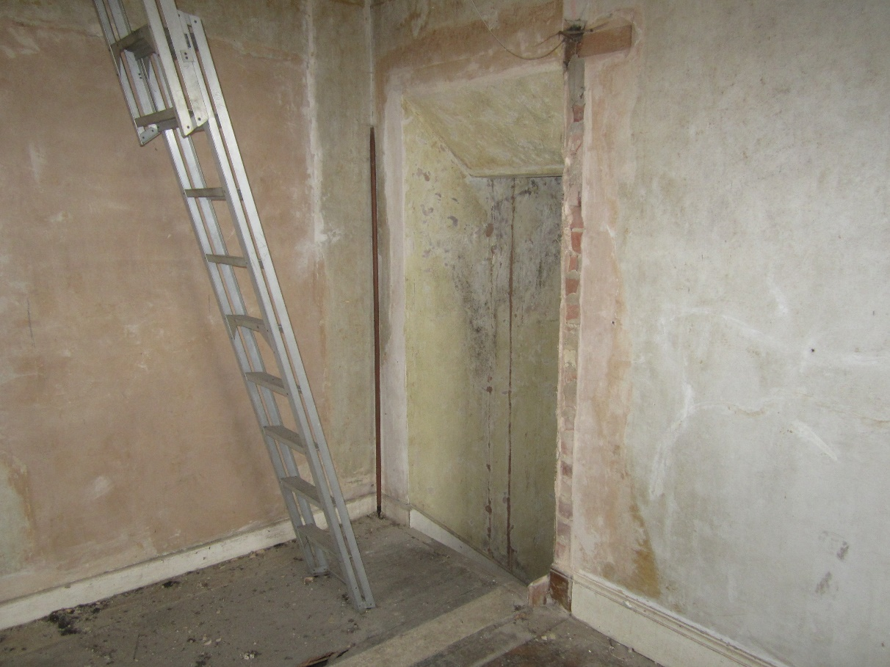
1. Existing opening at first floor level to be blocked up with stone to match existing external wall.
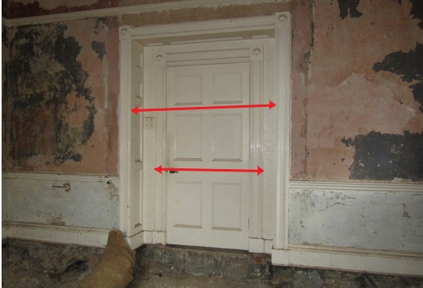
2. Original opening in rear (east) wall of original ground floor room at “Newcross”. Upper red line shows width of original opening. The lining and architrave are to be retained in situ and new joinery will be designed for this opening when the external surface can be revealed and explored. It may have dressed stonework around it. Lower red line shows original doorset, which was probably removed from the blocked opening between the original staircase hall and this room. It will be put aside for reinstatement via a subsequent application.
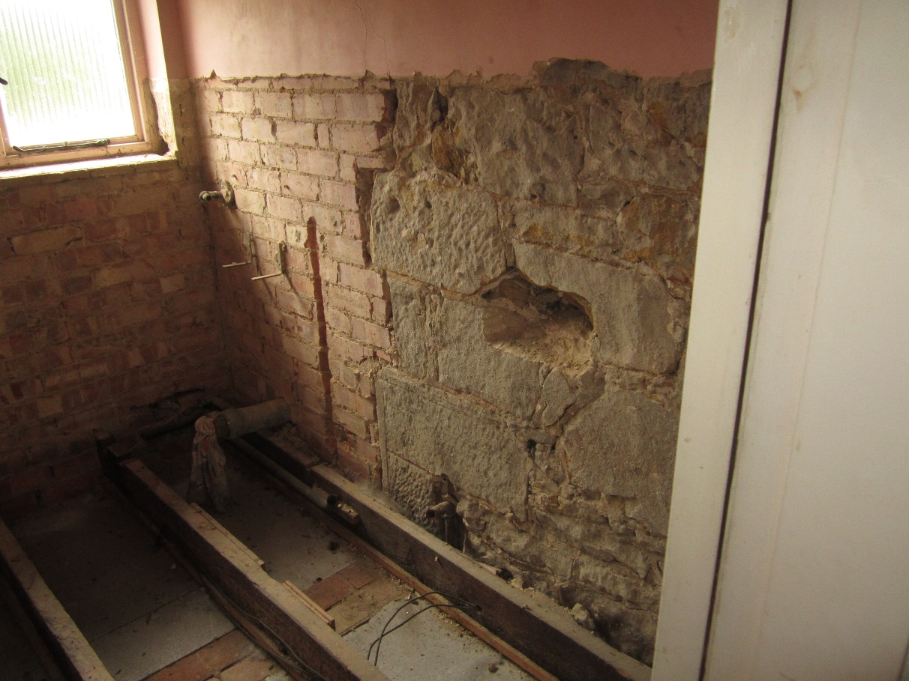
3. Exposed part of first floor stone wall (to become external) revealed by stripping out of first floor bathroom. This will be the finish of the rest of the exposed rear wall.
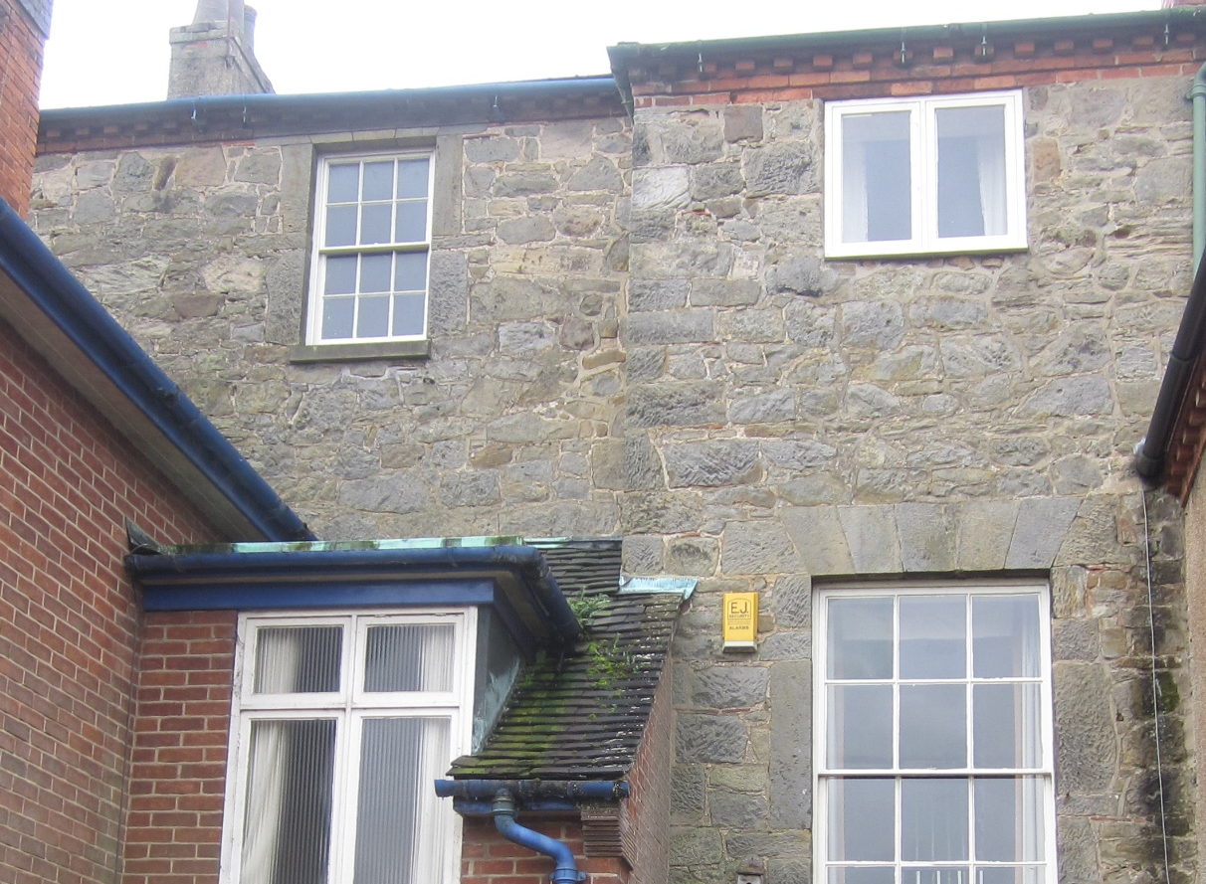
4. Photo of rear stone wall which will be further exposed following demolition, indicating the likely condition of the wall after existing internal plaster is removed.

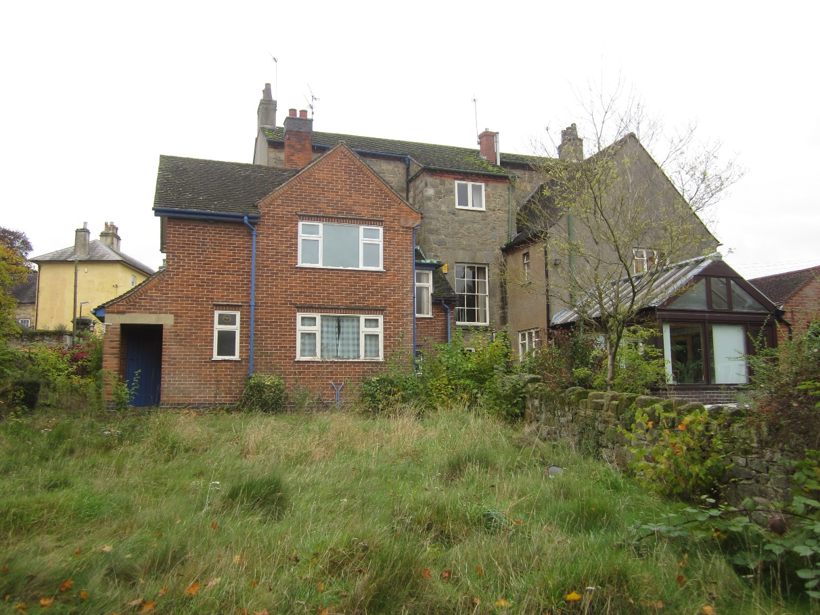
5 (above) and 6 (below) . General views showing brick-built extension to be removed.
