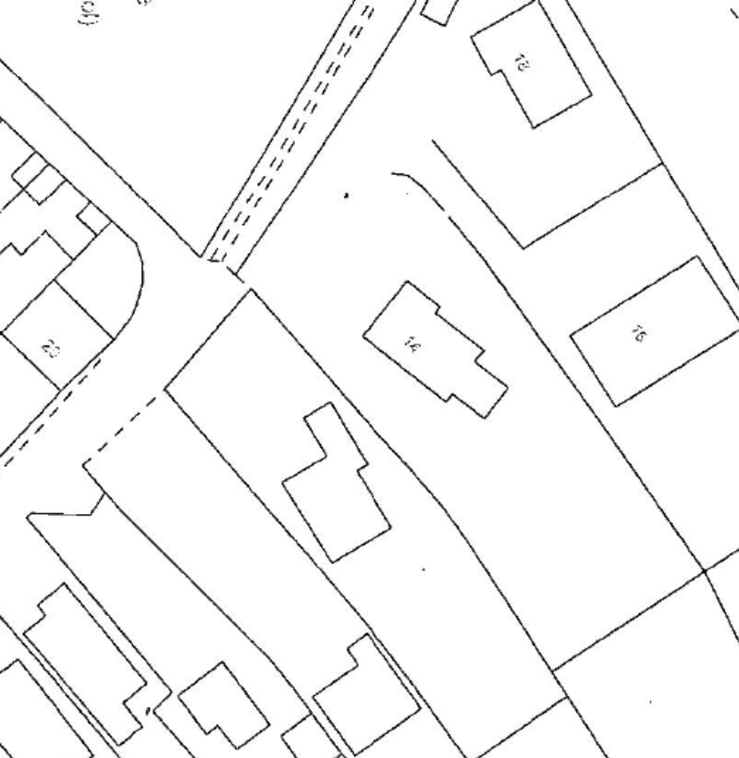
T1
The
Pastures
T1 | Magnolia | Fell

Locations of trees are approximate

Tree Works at 14 The Pastures, Repton | SK2/14 The Pastures | 20 August 2019 | Not to scale

