Approval of Conditions Discharge:
Application Reference – 9/2017/1084
Note – there was an error by the council on the Planning Approval form stating the Applicant as Mr and Mrs Ryan (suspect it was copy and pasted from a previous form). The applicant should read Mr and Mrs Gage.
Condition 3:
- Roof Tiles – will match current – Staffordshire Blue Plain Clay roof tiles.
- Bricks – Ibstock Ivanhoe Westminster
The property has a variety of different bricks with the cottage, boundary wall and single storey previous extension & garage all being of slightly different brick.
Picture 1 – photos of bricks of boundary wall and current cottage:
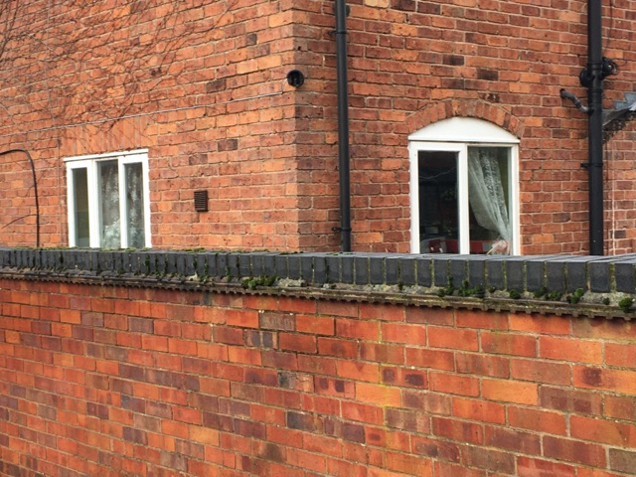
As can be seen the boundary wall and cottage have slightly different bricks.
Picture 2 – photos of bricks on a small previous single storey 1 room extension at the back of the cottage. The extension is the wall with the door on only.
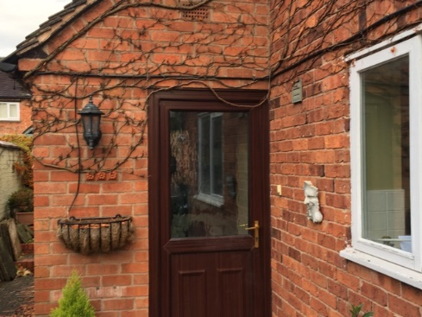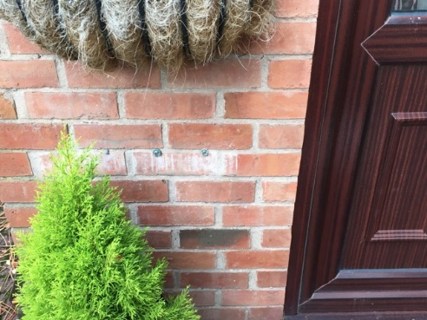
Picture 3 – stock photo and actual photo of proposed bricks Ibstock Ivanhoe Westminster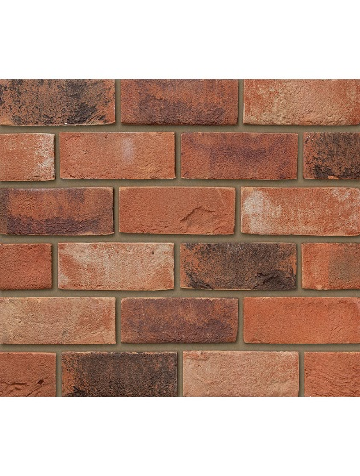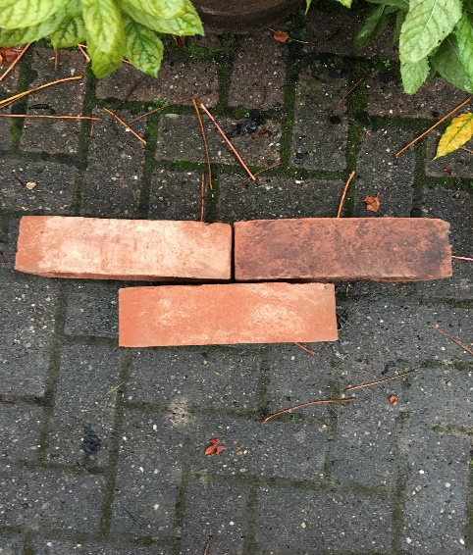
With the builder we have looked through the brick catalogue to match the bricks with the main cottage. As can be seen these bricks have a mix of darker and lighter bricks which will replicate what is already in place.
The foundations are laid and we plan to start laying the bricks c.20th November. We hope this is a very simple approval and would be very grateful if you could support these timescales to avoid delays and cost to the builder for inactivity.
Many thanks
George Gage

