Application for listed building consent for alterations at The Dower House, 81 London Road, Shardlow DE72 2GR
Introduction
The Dower House is a Grade 2 listed dwelling of Georgian origin with later Victorian additions. This application supplements a previous application for general renovation of the house and construction of a single storey extension to the rear for which permission was granted in July 2019. (See reference 09/2019/723).
Summary of proposal
In the original application, an existing window (referenced in the application as W06) in the rear entrance hallway was to be replaced with a suitable internal window between the new extension and rear entrance hallway with a design to be approved at a later date. Originally this was proposed to be a semicircular window. This was identified as Condition 4 in the planning decision document.
Our new proposal is to block up the opening, rather than fit an internal window. Listed building consent is sought in order to discharge the remaining planning condition.
Reference Photographs
The photos below show the external view of the window before the extension work was commenced and an internal view following installation of the supporting steelwork.
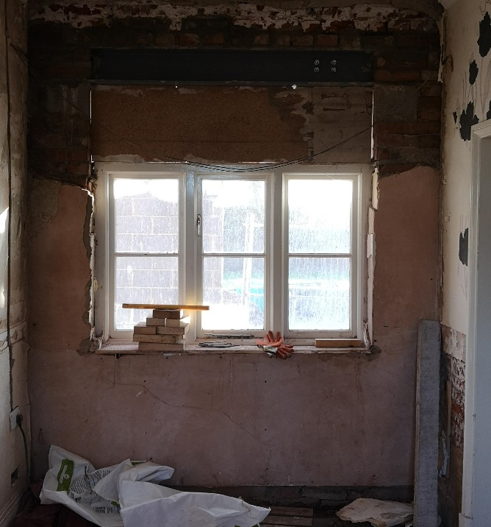
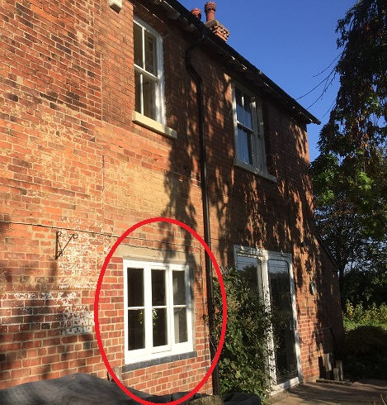

Detail of Works
- A structural steel has been fitted above the old window opening to allow a window opening to be created in future if so desired.
- The window opening is to be bricked up and plastered with 3 coats of lime plaster.
- Surrounding wall area to be skimmed with lime plaster following removal of old gypsum plaster skim on original internal facing wall. Note that lime plaster has been used throughout the new extension and other refurbishment areas to improve breathability of the original walls.
Heritage Impact Statement
The original window, most probably fitted in the renovations carried out in the 1980s, was approved for removal as part of the original application for construction of the new extension. The installation of the steel beam in accordance with the original building drawings will allow this work to be reversed without significant difficulty in future if so desired. Use of traditional lime mortar and plaster will remove inappropriate gypsum plaster from the wall.
Design and Access Statement
The proposed works return the building to its pre-1980s condition when the previous window was fitted. There is no impact on the historic fabric of the building.
The proposed works have no implications for access.

