Design & Access Statement

Swadlincote Market Hall Refurbishment

Prepared by YMD Boon Ltd
August 2025
Rev 01 – First Issue – 22/08/2025

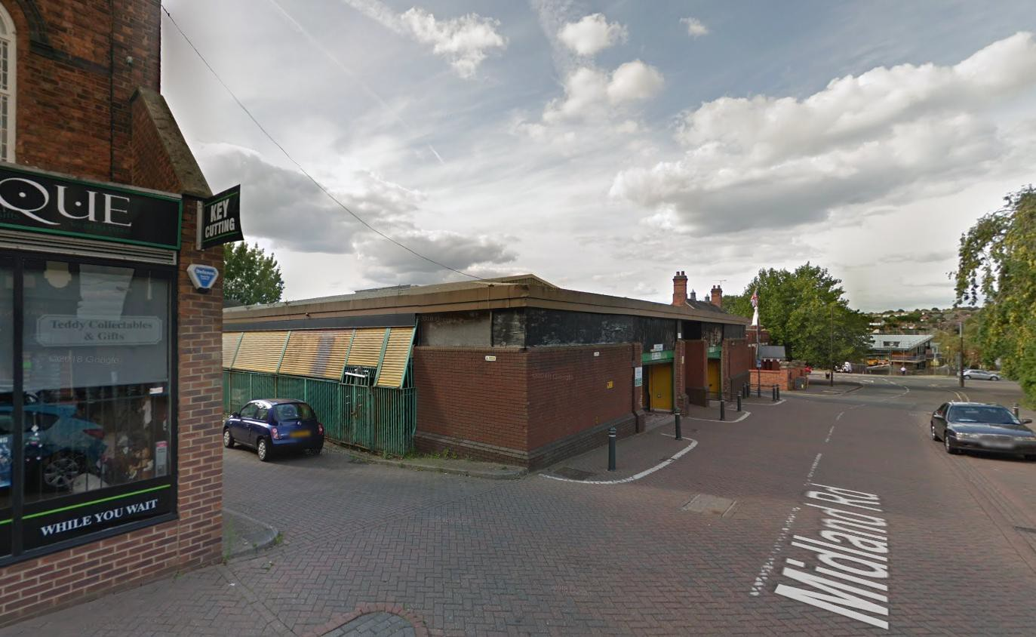

Introduction
This Design and Access Statement has been prepared to support the planning application for the refurbishment of the Market Hall, Midland Road, Swadlincote. The works aim to provide a more attractive and functional facility for car parking, market and community uses.

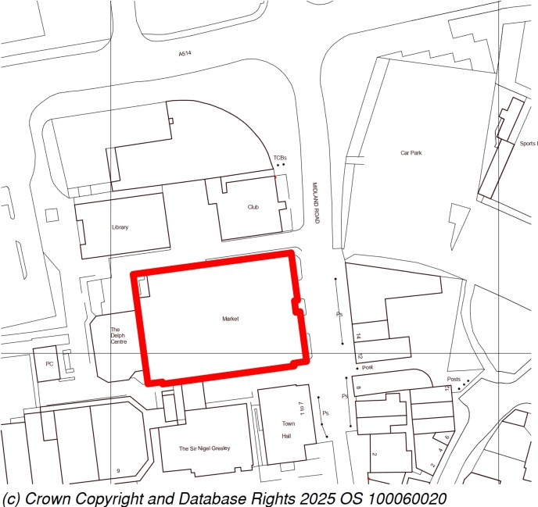

Site & Context
The Market Hall sits on Midland Road within the Swadlincote Conservation Area, surrounded by civic, retail and community uses. To the north lies the Swadlincote Constitutional Club, and to the south the Grade II listed Town Hall. The Market Hall itself, constructed in the 1980s, is identified within the Conservation Area Appraisal as a building of limited architectural merit that does not contribute positively to the streetscape. This application seeks to improve its relationship with the public realm and to better integrate the building into its historic setting.

Heritage Considerations
The accompanying Heritage Statement confirms that while the Market Hall is of low heritage significance, its proximity to notable heritage assets (the Constitutional Club and Town Hall) requires sensitive handling. The proposed works will enhance the
building’s appearance, reduce its negative impact on the conservation area, and secure
its long-term use.

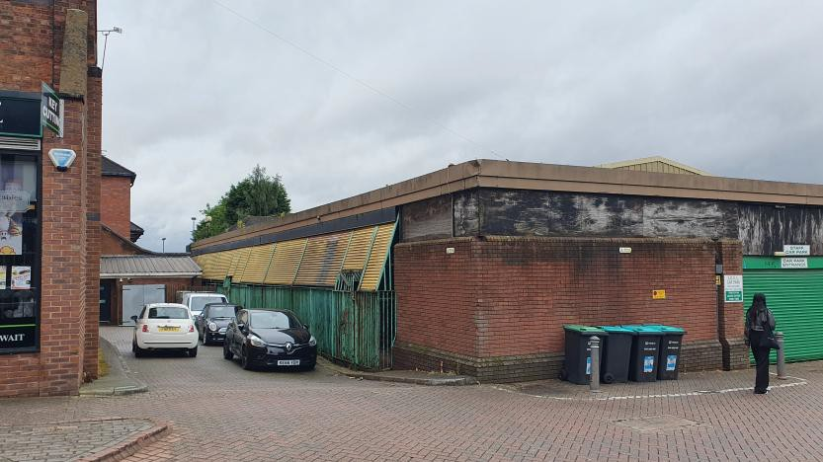
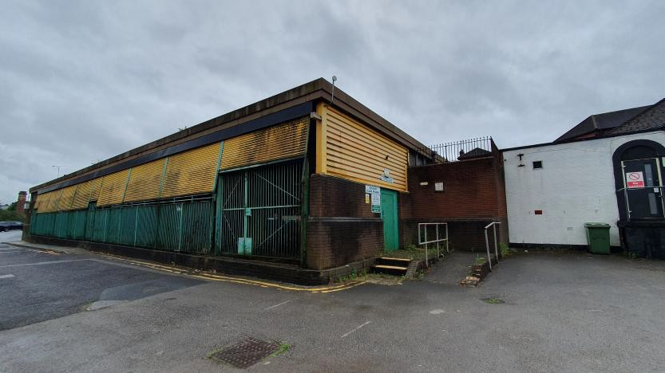
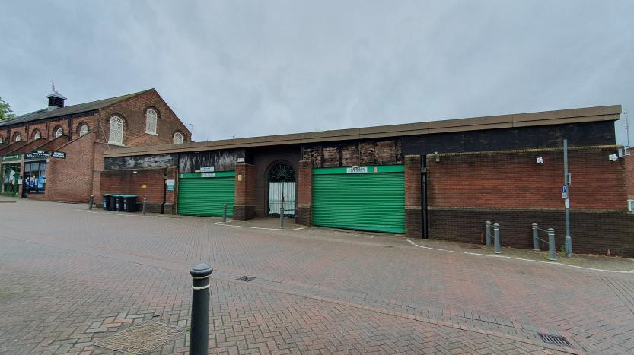

Existing Building Condition
A visual inspection has identified areas of age-related deterioration including roof defects, water ingress, and worn façades. Internally, layouts are outdated and in need of refurbishment.

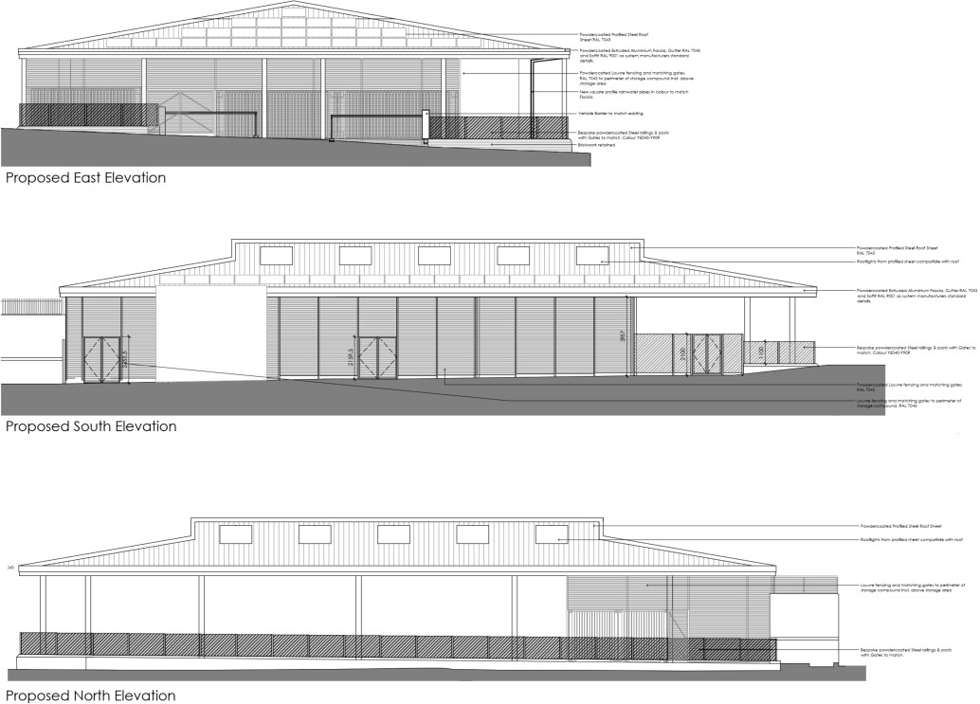

Proposals
No groundworks are proposed, and the scheme is limited to above-ground fabric and fit- out improvements.
The proposals include:
  - New louvred fencing and bespoke steel railings to improve security and visual coherence.
  - Upgraded entrances and gates, improving access and appearance.
  - Retention of vehicle barriers and improvements to pedestrian circulation.

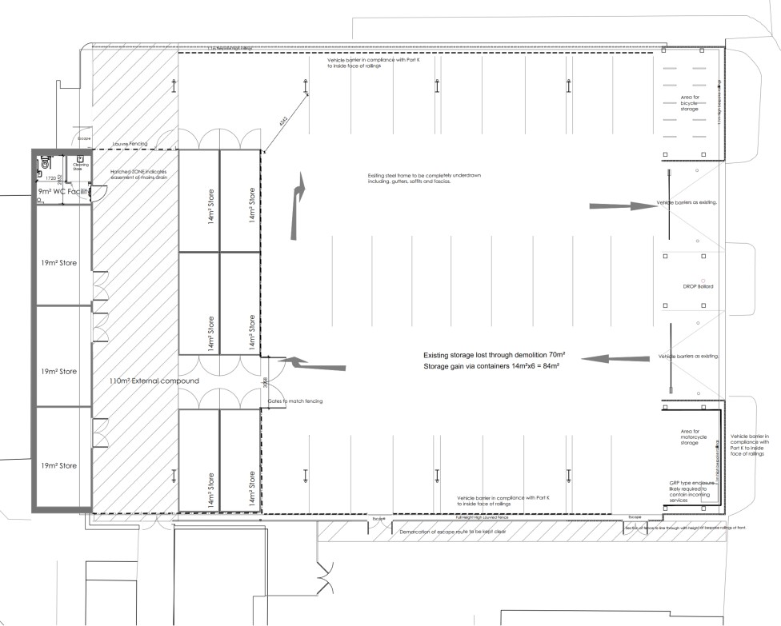

Access
The scheme provides improved and legible access arrangements. Escape routes are clearly demarcated, and secure cycle/motorcycle storage is incorporated. The building remains level-access throughout, ensuring inclusivity for all users.

Design Justification
The design approach balances functionality with sensitivity to the conservation area. While the Market Hall is not a heritage building in itself, the proposals represent a significant improvement in material quality, visual presence, and usability. This will support the Market Hall’s role as a civic and community space, improving its contribution to the local townscape.

Conclusion
The scheme, addresses existing building condition issues, upgrades its external appearance, and enhances accessibility. The proposals respect the setting of adjacent heritage assets while ensuring the Market Hall continues to serve the community as a flexible and sustainable facility. This Design and Access Statement should be read alongside the submitted Heritage Statement and drawings.

